Total Marks: | 4
Obtained Marks:

Web Technologies

Assignment # 02

Submitted To: Sir Zubair Ahmed
_______________________________________________________________________________________________________________________________________________________________________________________________________________________________________
Student Name: Ubaid Bin Waris
_______________________________________________________________________________________________________________________________________________________________________________________________________________________________________
Reg Number: 2212416 _______________________________________________________________________________________________________________________________________________________________________________________________________________________________________

Deployment on AWS

EC2 Instance

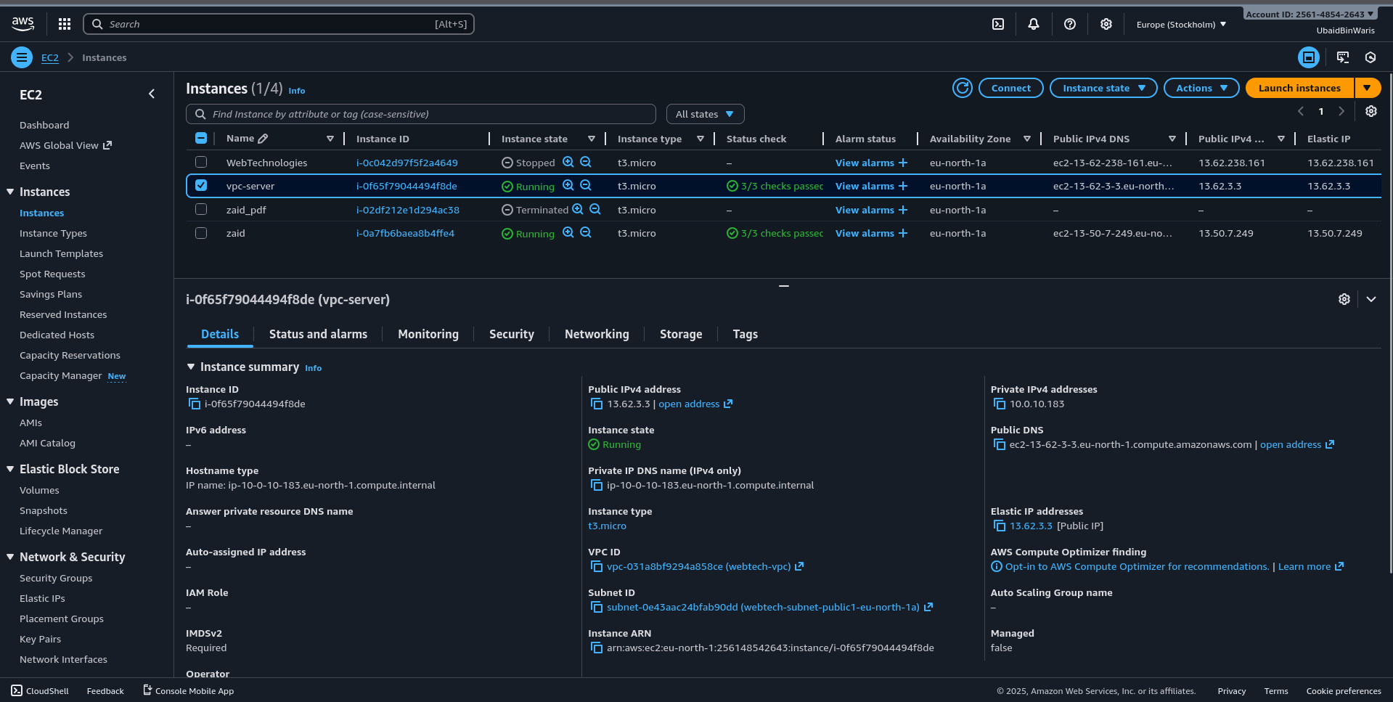

VPC

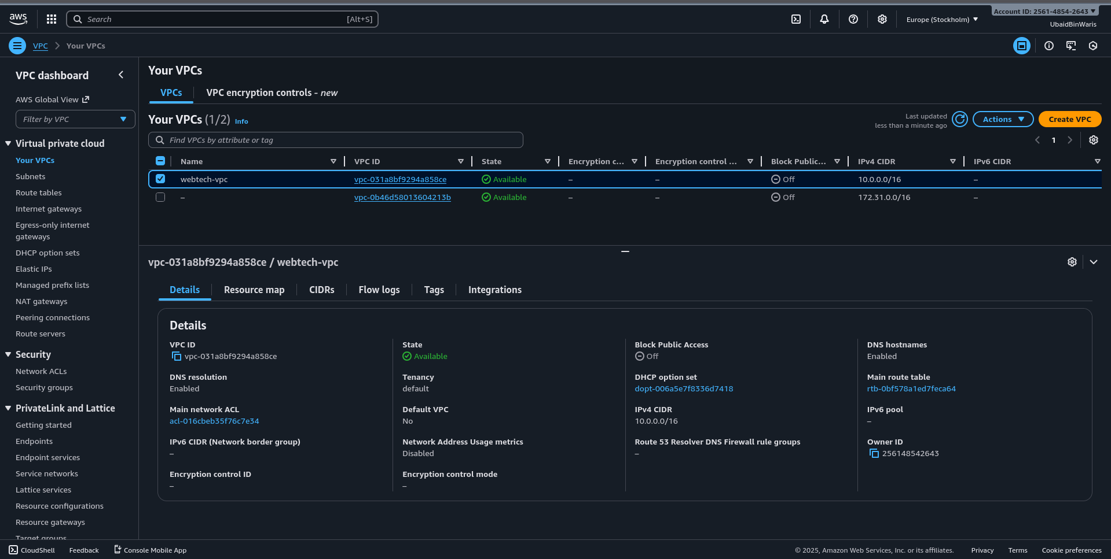

Subnets
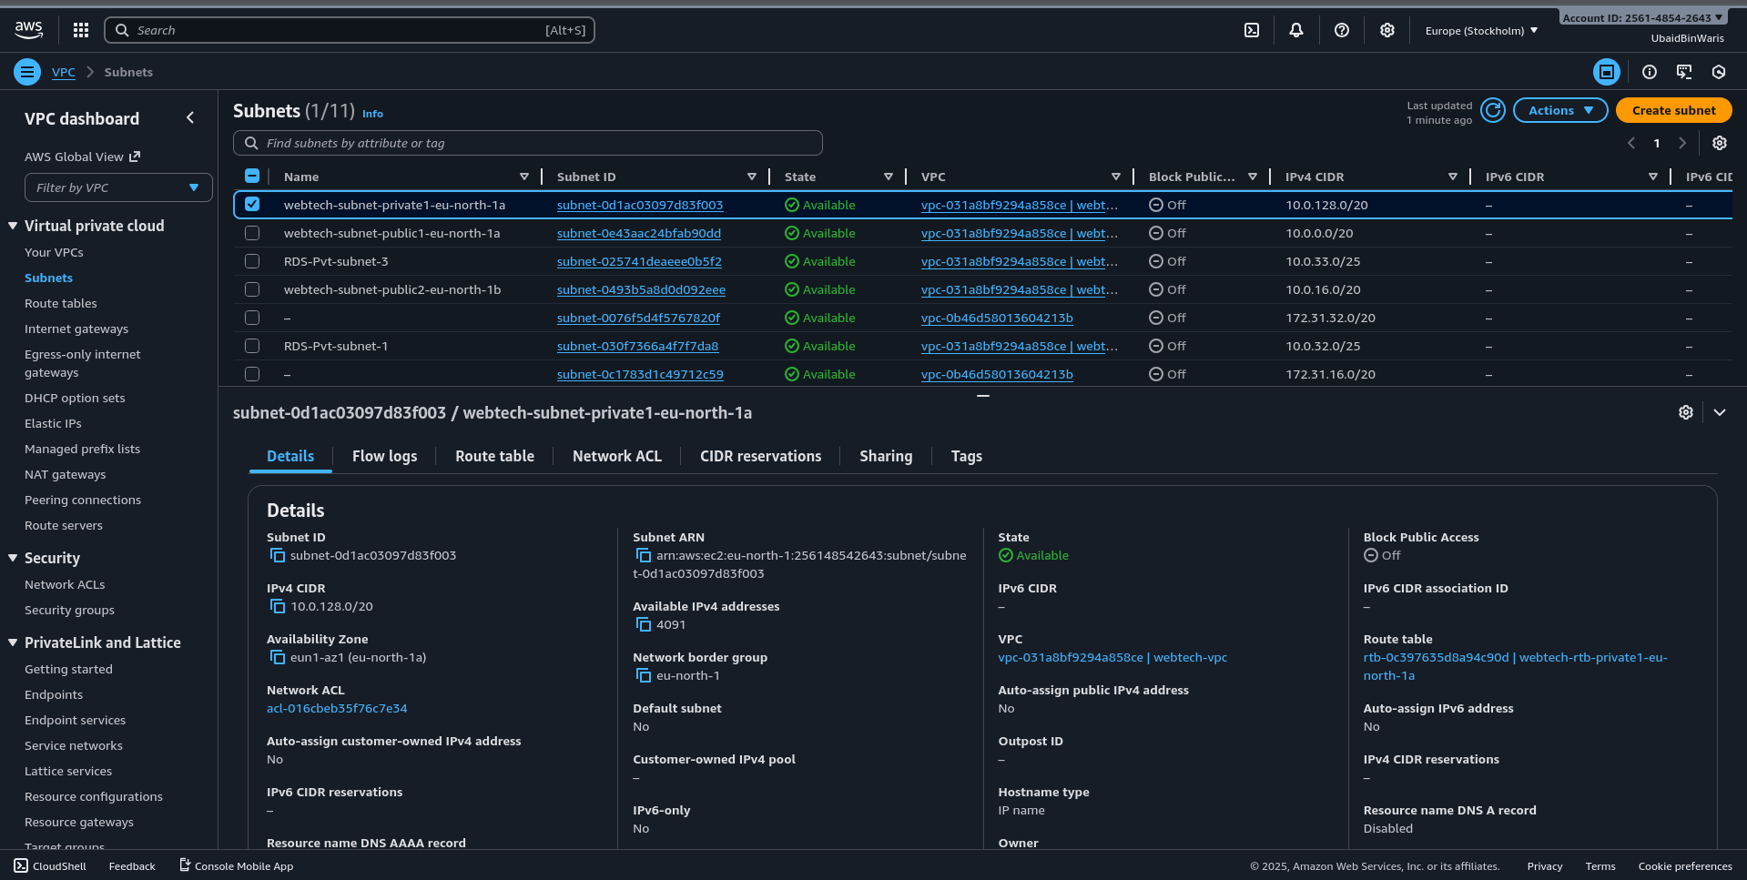

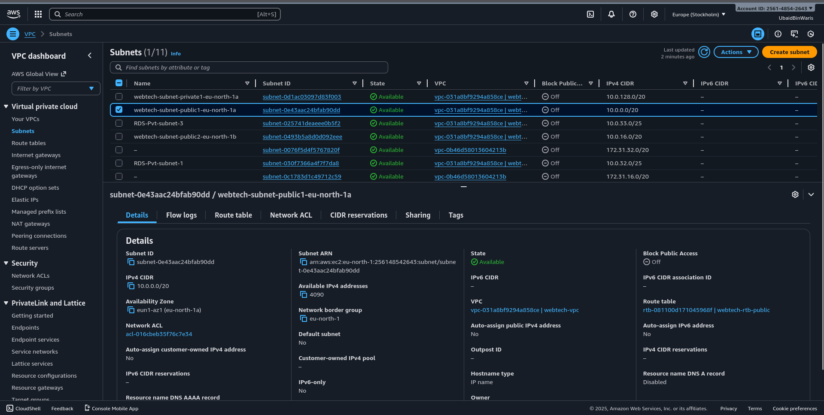

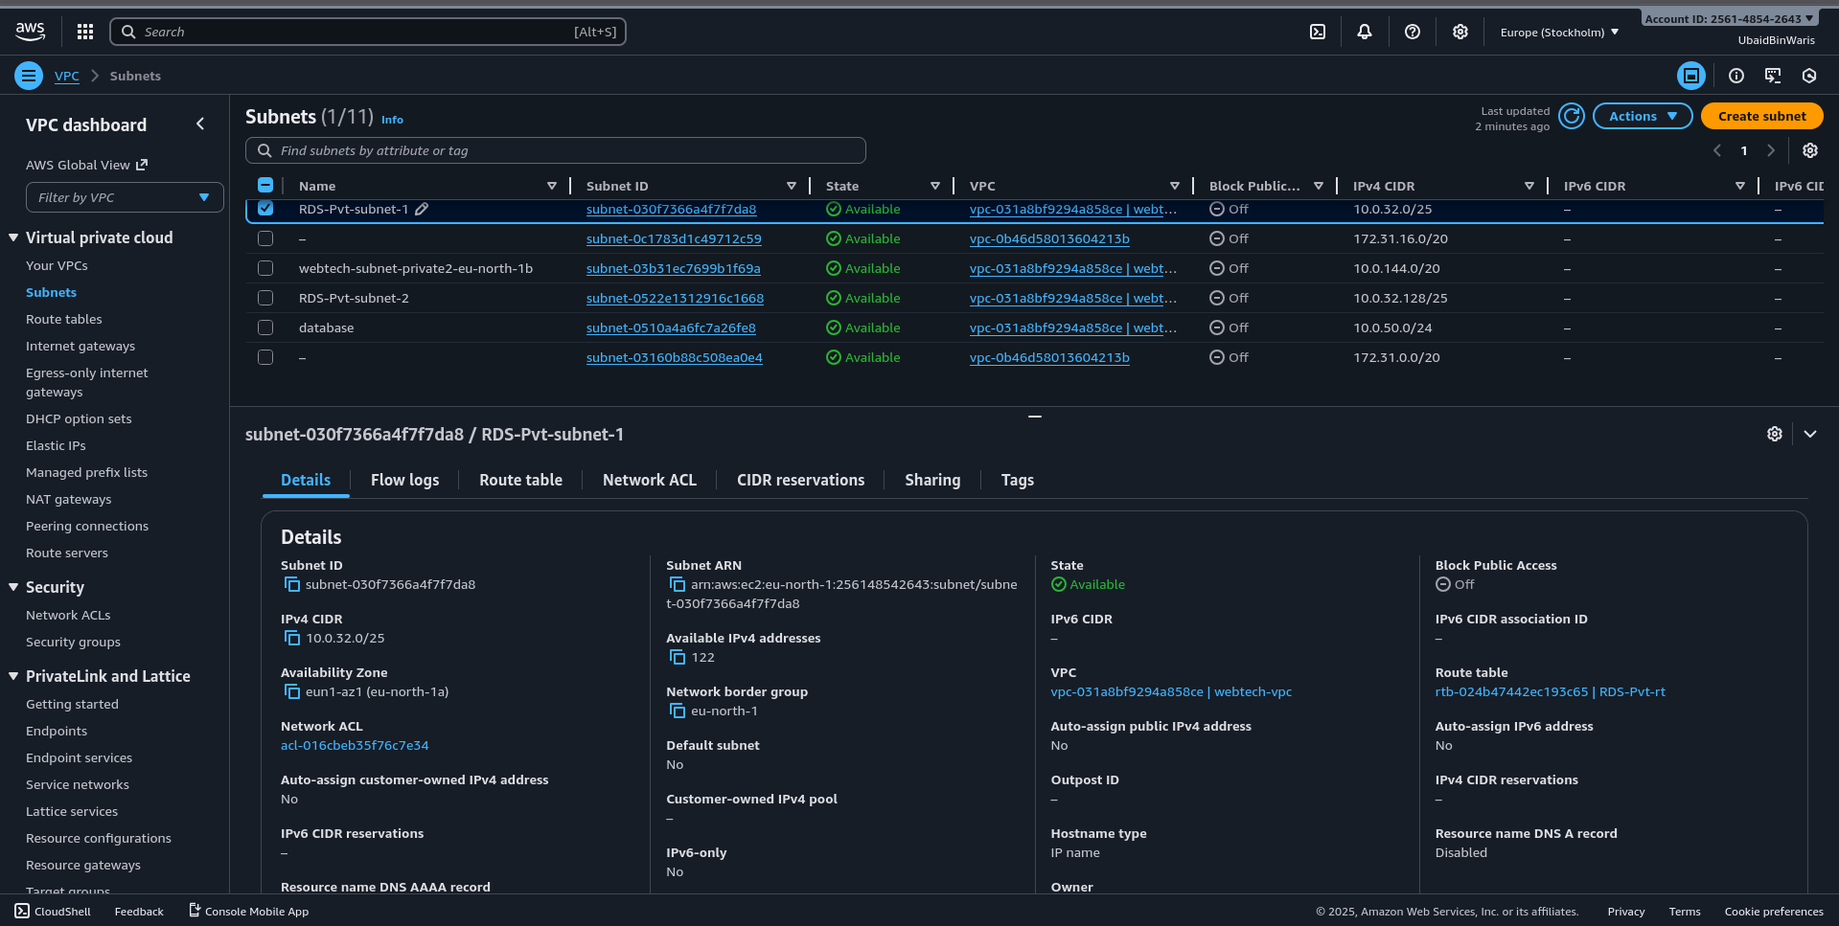

Route Table
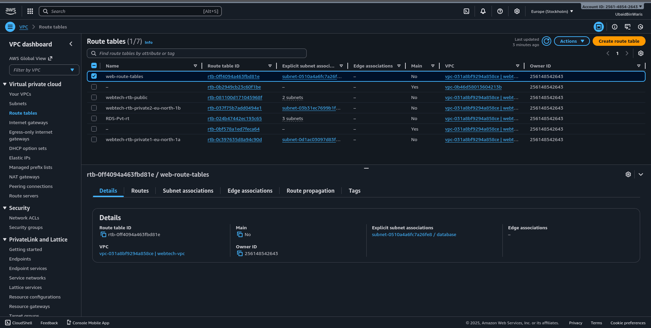

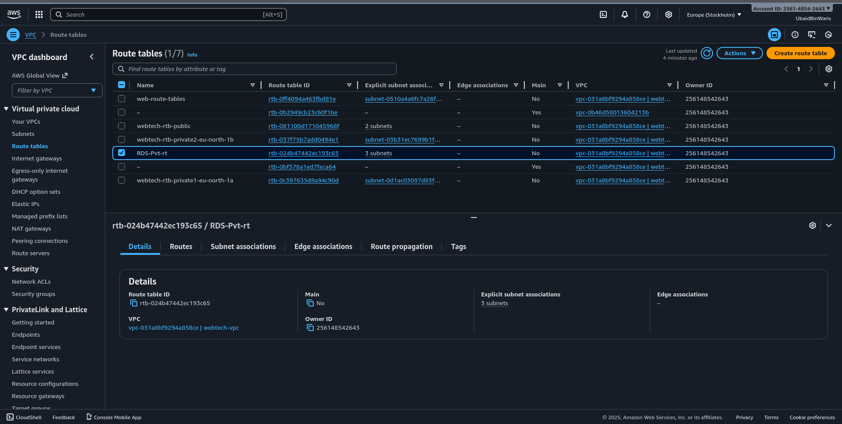

Internet gateway
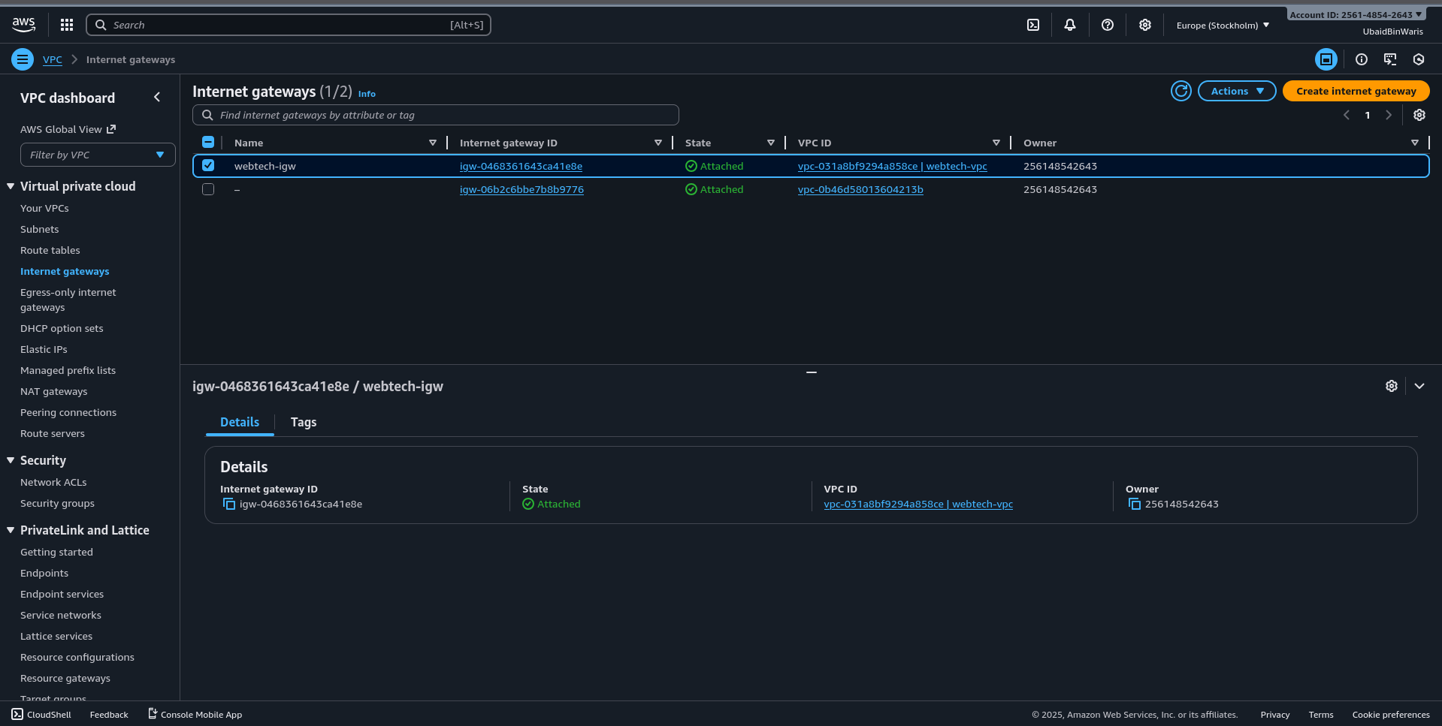

Security group
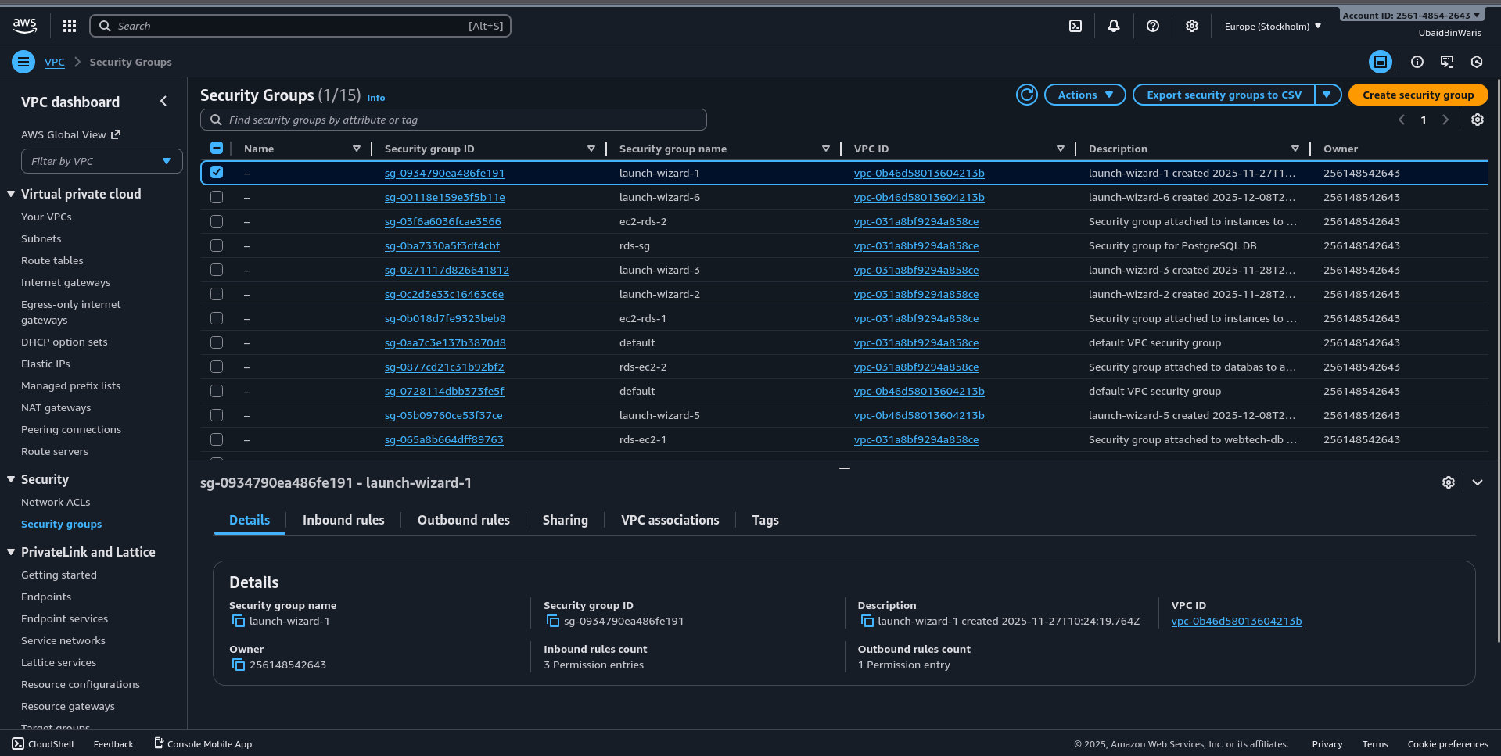

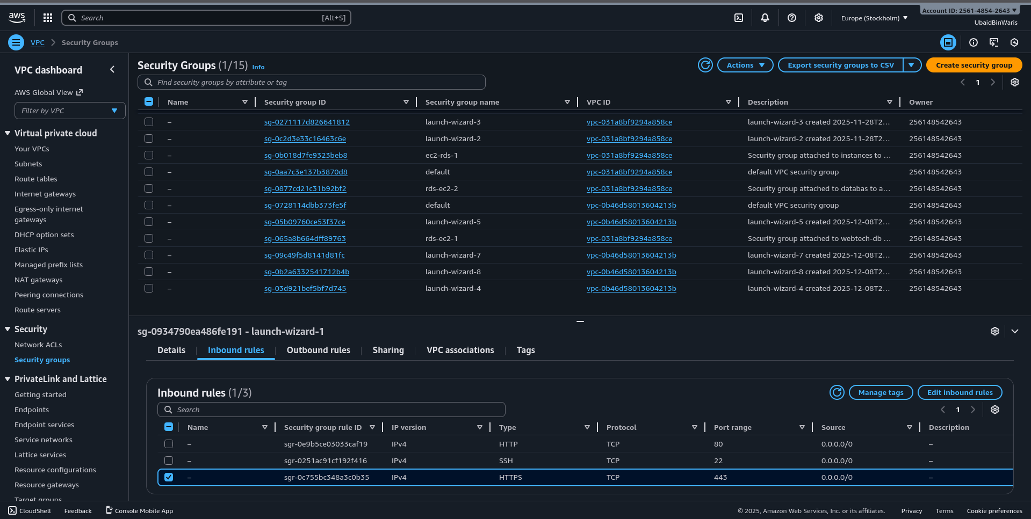

RDS
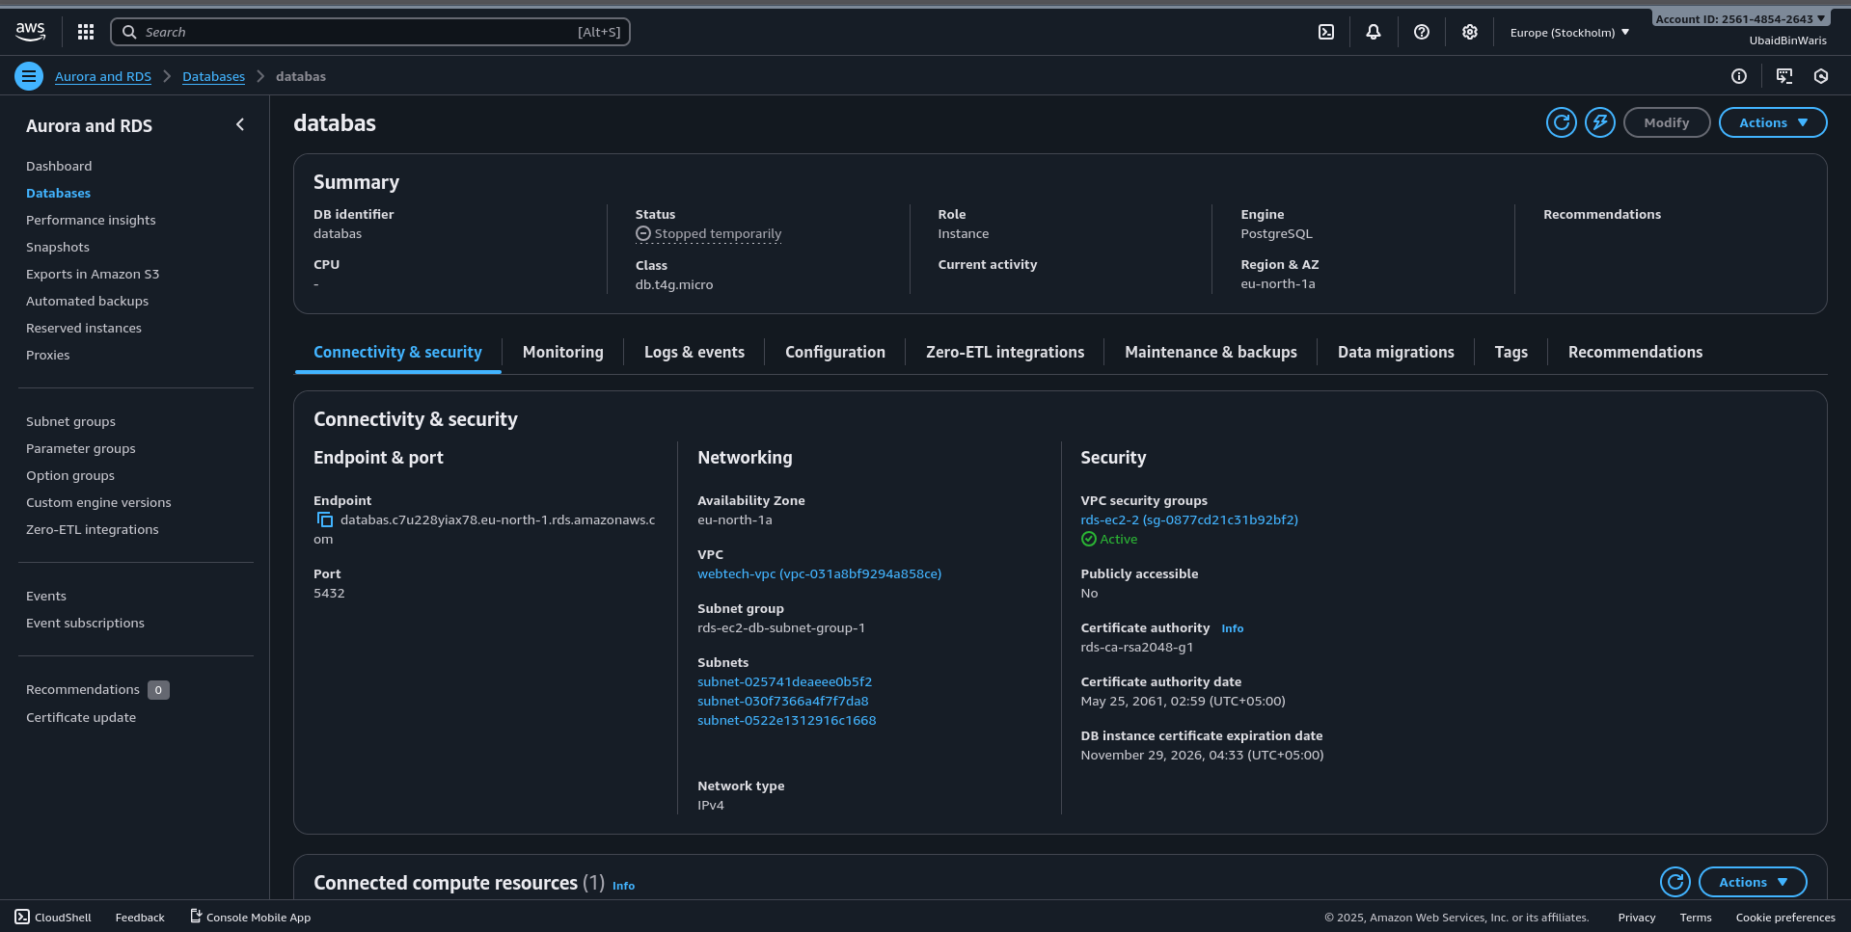

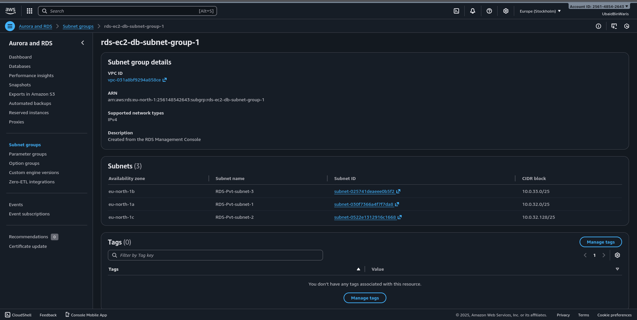

RDS connection with Instance
